**IS 340 – Operating Systems**

**HP05 – BASH – Looping and branching**

7/13/2019 Developed by Kevin Wang

06/17/2020 Reviewed by Kim Nguyen

Center for Information Assurance (CIAE) @City University of Seattle (CityU)

  

**Before You Start**

* This exercise assumes that the user is working with the Ubuntu 18.04 distribution. If you are working with a different Linux distribution, the set of shell commands may vary from those available in Ubuntu 18.04.
* Students will use the EC2 Ubuntu virtual machine that they created in the module 1 exercise.
* All commands and code discussed in this exercise will run in the Ubuntu console.
* The directory path shown in screenshots may be different from yours.
* Some steps are not explained in the tutorial**.** If you are not sure what to do:
  1. Consult the resources listed below and experiment in the Ubuntu console and try to solve the problem yourself.
  2. If you cannot solve the problem after a few tries, ask a TA for help.

**Learning Outcomes**

Students will be able to:

* Use test command
* Understand the conditional execution
* Use input/Output, pipeline, and command substitution

**Resources**

# Linux command line: bash + utilities

<https://ss64.com/bash/>

* Nano/Basics Guide

<https://wiki.gentoo.org/wiki/Nano/Basics_Guide>

**Preparation**

1. Connect to your Ubuntu instance

Open a command prompt

Syntax: ssh -i LOCATION_OF_YOUR_KEY ubuntu@PUBLIC_DNS

Example:

>>>ssh -i key.pem ubuntu@ec2-33-222-101-222.us-west-2.compute.amazonaws.com

1. Navigate to your name directory under the IS340-Summer-2020

>>> cd ~/ IS340-Summer-2020/YOURNAME

Note: change YOURNAME to your real name

1. Create a Module5 directory under YOURNAME directory.

Note: If this directory exists, skip this step.

>>> mkdir Module5

1. Navigate to the Module5 directory.

>>> cd Module5

**Basic usage of the test command**

1. Type the following command to test integers:

>>> test 1 -eq 1

Note: -eq for equal, -ne for not equal, -gt for greater than, -lt for less than, -ge for greater or equal, -le for less or equal.

1. Check the result by typing:

>>> echo $?

Note: $? is a special parameter that contains the exit code for the last command. 0 means successful when 1 means error. When we use a test command, 0 means true and 1 means false.



1. [] is the equivalent of test. We can test an integer like this:

>>> [ 1 -lt -2 ]

And then, retrieve the result:

>>> echo $?



Note: Linux Bash script is case sensitive as well as space sensitive. For using the [], we have to keep a space after [ and before ].

1. Use [[]] to test a regular expression

>>> [[ abc =~ ^a.*c$ ]]

And retrieve the result

>>> echo $?



**Note: We will practice more regular expression in other modules.**

1. Use (()) to evaluate an arithmetic expression. (This is a nonstandard feature)

>>> (( 2 - 1 ))

>>> echo $?

>>> (( 1 - 1 ))

>>> echo $?

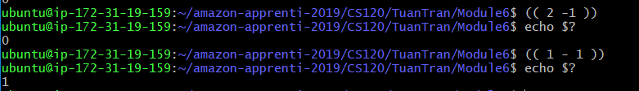

In Linux, when arithmetic expression value is 0, it will return False. Otherwise, a true will be returned.

**If conditional execution**

1. The basic syntax of if command shows below:

if <condition list>

then

<list>

elif <condition list>

then

<list>

else

<list>

fi

1. Create a ConditionTest.sh file by typing following command:

>>> nano ConditionTest.sh

1. Type the following script in the file:

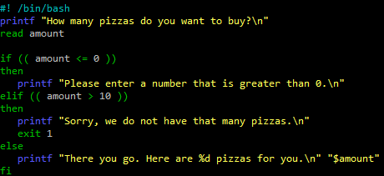

1. Hit the control + x key to quit and save the file.
2. Type the following command to execute the script:

>>> bash ConditionTest.sh

Then type in a number to test it. Please run the program several times to try different numbers.

**Case condition execution**

1. The basic syntax for “case”:

case WORD in

PATTERN) COMMANDS ;;

PATTERN) COMMANDS ;; ## optional

esac

1. Create a CaseTest.sh file by typing the following command:

>>> nano CaseTest.sh

1. Type the following script in the file:

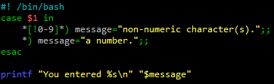

1. Hit the control + x key to quit and save the file.
2. Type the following command to see the result

>>> bash CaseTest.sh 10

>>> bash CaseTest.sh string

**Looping**

1. Type the following command to create a WhileTest.sh file:

>>> nano WhileTest.sh

1. Type the following script in the file:

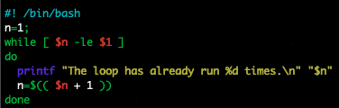

1. Click the control + x key to quit and save

1. Type the following command to test the file. You can give a different number to the parameter.

>>> bash WhileTest.sh 10

1. An Until loop is the opposite of while loop, which will run the code as long as the condition fails.

Type the following command to create a UntilTest.sh file:

>>> nano UntilTest.sh

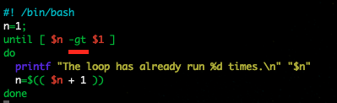

1. Click the control + x key to quit and save.
2. Type the following command to test the file:

>>> bash UntilTest.sh 5

1. Another common loop is for loop. Type the following command to create a ForTest.sh file:

>>> nano ForTest.sh

1. Type the following script in the file:

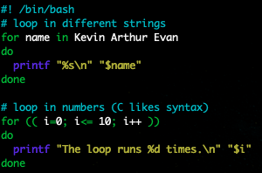

1. Click the control + x key to quit and save.
2. Type the following command to test the file:

>>> bash ForTest.sh

**Push your work to GitHub**

Run the following commands to push your work to the GitHub repository:

>>> git add .

>>> git commit -m “Submission for Module 5”

>>> git push origin YOUR_BRANCH_NAME

Note: you should change the YOUR_BRANCH_NAME to your own branch name. It should be firstname-lastname (e.g. maria-gracia).

If you cannot remember, run the command “git status” to check.